San Leandro
DAHLIA TIMES

Editor: Barry Hart October, 2016
BHart2@aol.com

Next Meeting: Oct. 18, 7:00 PM
Karp Room, San Leandro Library

Dahlia folks,
As JoAnna and I look out at our dahlia garden, we can tell it is fall. The plants are looking bad. From a distance, the colors are still nice but up close the blooms have fewer petals and are smaller. We haven't cut spent blooms for about two weeks and the spent blooms are turning into seed pods. The stalks are starting to fail and the plants are falling over on each other. I want each of you to think back at this year and discover what you have learned from your garden. I can tell you that I learned that my lungs cannot take mildew spores. I thought I could spray with baking soda, a bit of dish washing soap and vinegar and I would be fine without a mask. The spraying blew up the spores and without a mask I inhaled the spores and had breathing problems for several weeks. I know that the new growers have learned a lot about grooming and tending their plants making them show worthy. This seems like a good time to congratulate Louise Henriksen as she won novice sweepstakes three times in a row making her new status amateur. Good going Louise!!
We will have a couple of plant subjects going on at our meeting, one of which will be digging and taking the tubers with good eyes off the clump. This is always a good refresher for the new grower as well as seasoned gardeners. We'll also learn a bit about vermiculture!
As we often say, if anyone has any subject they want to have meeting time on, please let us know. We always are up for suggestions. By the way, having Jan Palia come and speak on displaying our favorite flowers was a great idea. I have had several people say that was the best meeting since the last time she was here. Everyone got to participate and the displays were dazzling. One person wanted to take pictures and make a calendar with the displays that were made.
See you at the meeting.
John
Refreshments will be provided by:
Idelina and Maren
Next month:
? ? ?
San Leandro Dahlia Society
Minutes: Sept. 20, 2016 Meeting
San Leandro Library - Karp Room - 7:00 PM

Presiding --- John Morton - Members present 23
Treasurer --- -Absent, no report

Old business---- Yearly library donation. Past history $500.00. Show of hands indicated desire to keep the same amount. Still no response from personnel regarding problem of table numbers for our Aug dahlia show.
Will ask for vote at Oct. or Nov. meeting as to need for a Jan. meeting.

New Business---Note change of yearly dues.
Single ADS= 27.00 ADS= 30.00 Beverly will take dues ''any time''

Program Event: Jan Palia, floral designer from Monterey area joined us for a 2nd visit. She demonstrated with 2 arrangements.
Among her comments:
1. build sculpture
2. less is better
3. not jamming in
4. with fillers, create depth and interest to show of dahlias.
5. size of vase determines arrangement
6. old fashioned bouquets tend to be less formal and more
filler.
Opportunity followed for members to create their own arrangements under her guidance.

Adjourned after refreshments

Minutes submitted by Maren Giannini

Vermiculture: Don't put food waste down the disposal - use worms to eat it and produce great fertilizer! These are the "red wigglers" that do all the work fo

We'll also learn about how to dig up our dahlia clumps and cut them into viable sources for next season's flowers!

Our September meeting was enjoyed by all! Jan Palia showed us how to make arrangements and then we got a chance to make our own. Here are a few pages of photos... the first one shows Jan doing the demo. Flower by flower, Jan's arrangements grew...
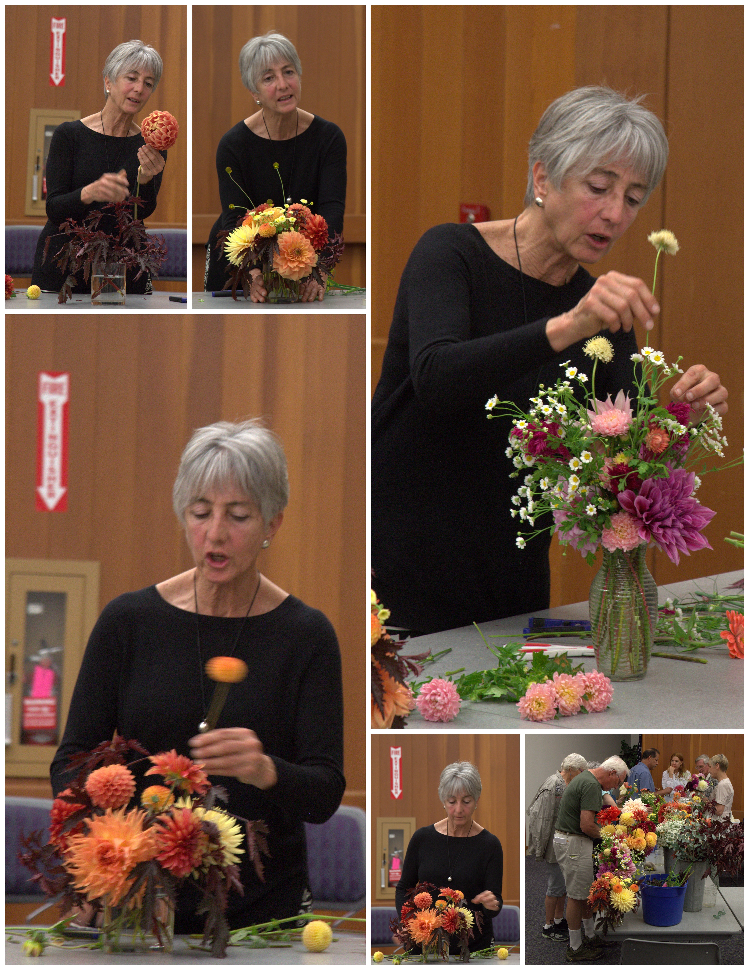

Here we are... putting together our arrangements...
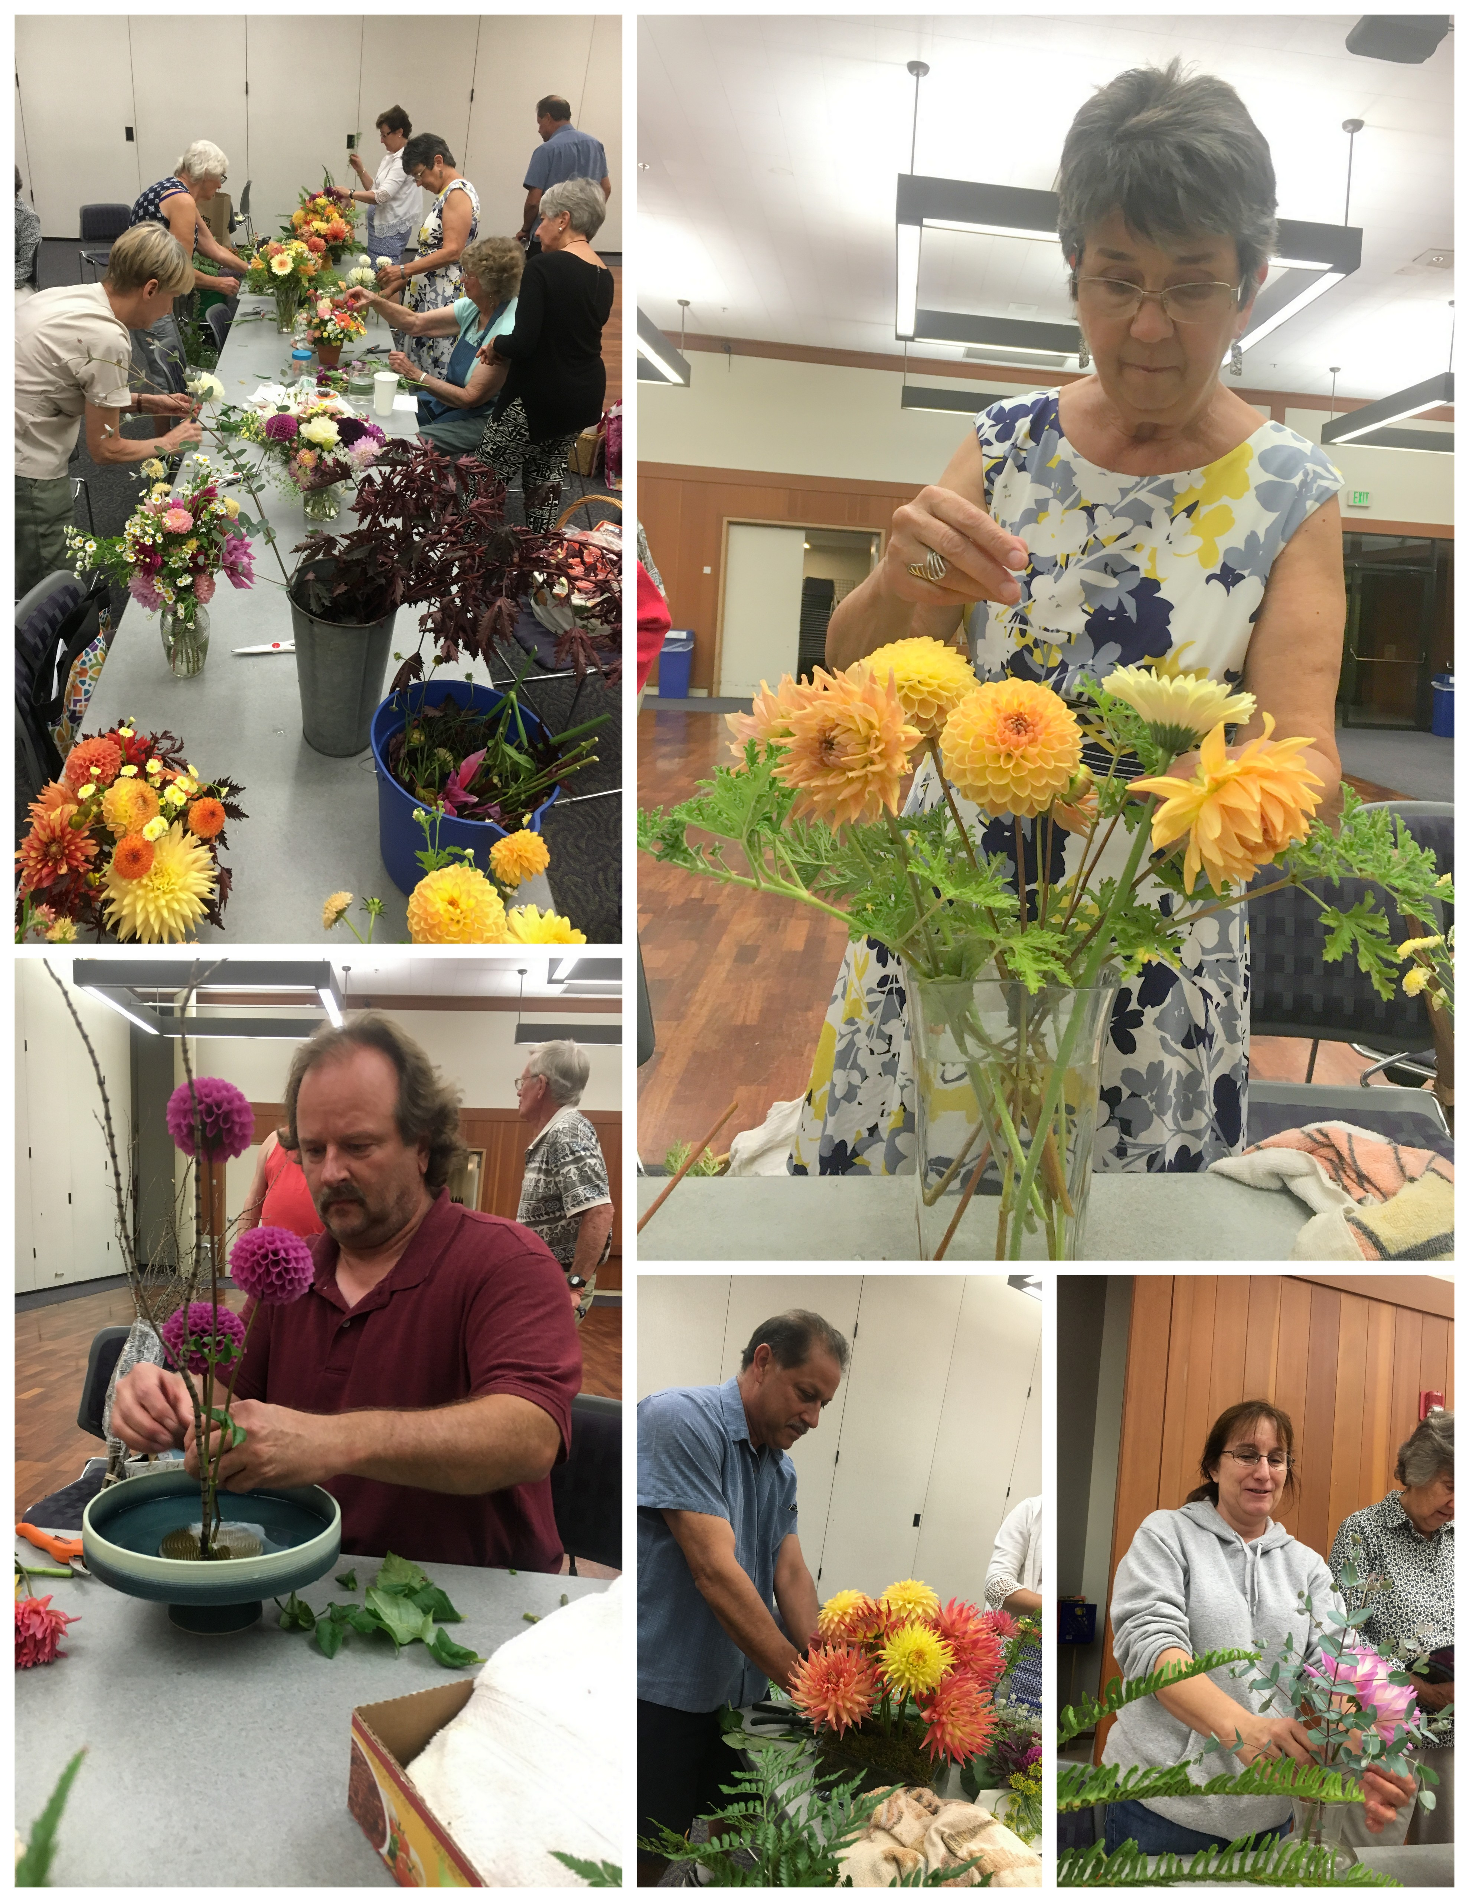

We did a great job... Our creations were beautiful!


